Internal Parking Mechanism Version 2

Contents
Overview 2
Setup 3
Electrical Specifications 4
Cable Specifications 4
Package Contents 5
Dimensions 6
Contact Information 7

Overview:
IPM (Internal Parking Mechanism) is a PWM test module designed to actuate the rotary solenoid to select the transmission into different modes for testing. The IPM module reads the position of the rotor and the position of two linear sensors. The position will be shown on the LCD display but can also be read on four (4) BNC outputs (two linear, one digital, and one rotary). There are three states:
- Park
- Not Park
- Stay Out of Park
Switching to these states can be achieved by pressing any of the three buttons located on the top of the IPM module.

The limits for the rotor and linear sensor positions for each parking state are:
Internal Parking Mechanism Version 2 Sensor Limits
Position | Linear Sensor 1 Range (%duty) | Linear Sensor 2 Range (%duty) | Rotary Range (%duty)
Park | 4-15 | 85-96 | 25.5-29.5
Not Park | 74-96 | 4-26 | 25.5-29.5
Stay Out of Park | 74-96 | 4-26 | 74-80

Setup:
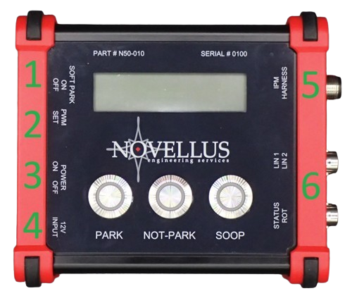
- Enable or disable soft park

- Change the PWM

- Ensure the IPM module is powered off

- Connect the power cord to the IPM

- Connect the target module

- (Optional) Connect an oscilloscope input to the BNC connectors

When ready, flip the power switch (3) from OFF to ON

Electrical Specifications:
Signal | Minimum | Maximum
Input Voltage | +9 VDC | +16 VDC
Output Current | 1A | 5A
Operational Temperature Range | 0°C | +85°C

Cable Specifications:
Resource | Cable # | DB15 | 40-Pin Bulkhead | 26-Pin BEV Bulk.
DLPS2 Ground | 1 | 1 | 9 | 19
DLPS1 Ground | 2 | 2 | 20 | 18
Rotary PWM In | 3 | 3 | 8 | 1
Controller Ground | 4 | 4 | 10 | 17
DLPS2 PWM Out | 5 | 5 | 18 | 6
DLPS2 +5V | 6 | 6 | 29 | 12
DLPS1 +5V | 7 | 10 | 39 | 11
Solenoid - | 8 | 11 | 19 | 15
Solenoid + | 9 | 12 | 30 | 14
Controller +12V | 10 | 13 | 40 | 10
Rotary PWM Out | 11 | 14 | 28 | 4
DLPS1 PWM Out | 12 | 15 | 38 | 5

Note: Red pins are larger pins

Package Contents:
- (1) IPM Box

- (1) Power supply

- (1) 8m signal cable (un-terminated)
- Terminated cables are available upon request; Customer to provide connectors

Note: More accessories are available upon request. Please contact Novellus Engineering Services for more information.

Dimensions:
138 x 116 x 56 mm (Length x Width x Height)
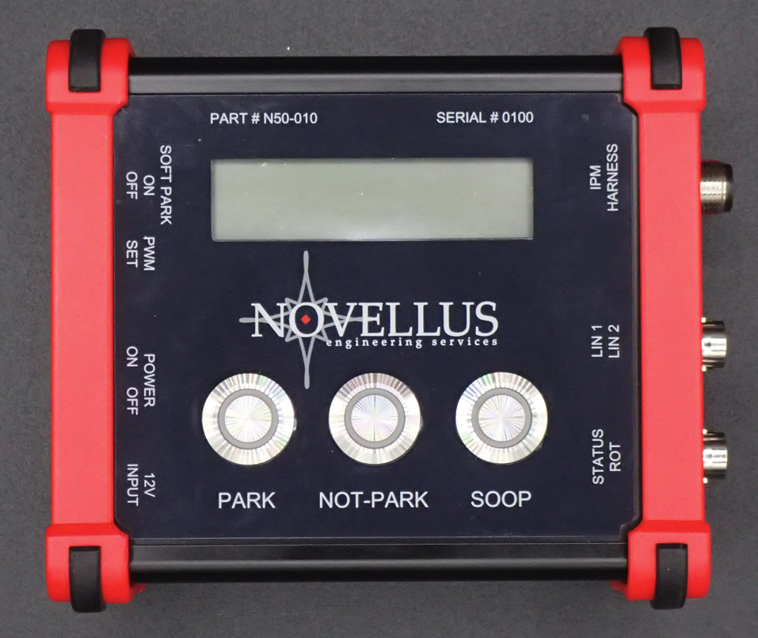
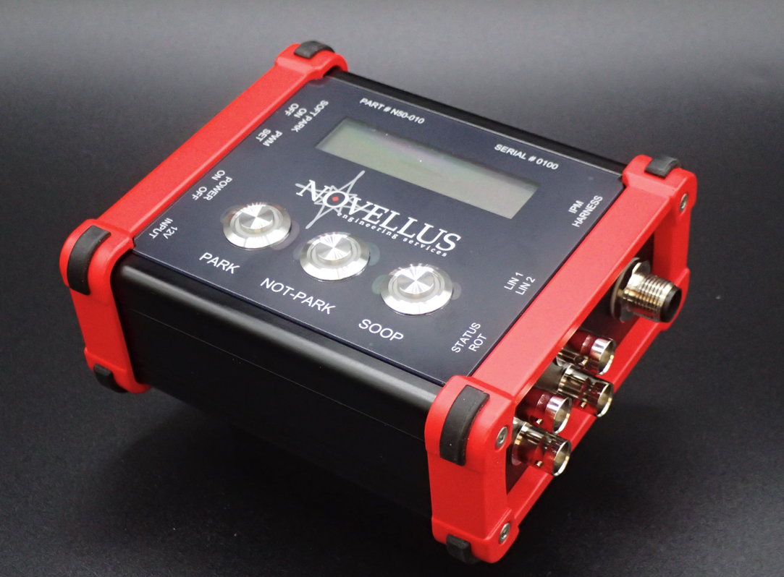
Contact Information:
Novellus Engineering Services, Inc
44720 Helm St, Plymouth, MI 48170
(734) 355-7307
https://novelluseng.com/

